|  |
| --- |
| **Front End Engineering-II**    Project Report  Semester-IV (Batch-2022)      Title of the Project:  IMAGE CAROUSAL ( BOOTSTRAP)      **Supervised By:**  **Submitted By:**  Faculty Name: Raveesh Samkaria Name: Sanyam Bhatia  Roll Number (Group):  2210990795  G-12      **Department of Computer Science and Engineering**  Chitkara University Institute of Engineering & Technology,  **Chitkara University, Punjab** |

**INTRODUCTION**

The Bootstrap Carousel is a powerful and versatile component offered by the Bootstrap framework, designed to create dynamic and visually appealing image slideshows or carousels on web pages. With its intuitive structure and extensive customization options, the Bootstrap Carousel empowers developers to craft engaging and interactive user experiences.

At its core, the Bootstrap Carousel operates on a simple principle: it cycles through a series of images or content panels, allowing users to navigate through them manually or automatically. This makes it ideal for showcasing product images, portfolio items, featured articles, or any other content that benefits from a visually engaging presentation.

One of the key features of the Bootstrap Carousel is its responsiveness. It automatically adjusts to different screen sizes and devices, ensuring a seamless viewing experience across desktops, tablets, and smartphones. This responsiveness is achieved through Bootstrap's built-in grid system and flexible layout components, making it easy to create carousels that look great on any device.

Furthermore, the Bootstrap Carousel offers extensive customization options, allowing developers to tailor its appearance and behavior to suit their specific needs. From controlling the transition effects between slides to adding navigation arrows and indicators, developers have full control over every aspect of the carousel's design and functionality.

Additionally, the Bootstrap Carousel is highly extensible and integrates seamlessly with other Bootstrap components and JavaScript libraries. This means developers can enhance its functionality with features like touch swipe support, keyboard navigation, and more, to create richer and more interactive user experiences.

In conclusion, the Bootstrap Carousel is a versatile and powerful tool for creating engaging image slideshows and carousels on websites. With its responsive design, extensive customization options, and seamless integration with other web technologies, it empowers developers to deliver captivating and immersive content experiences to their users.

**Folder Structure**

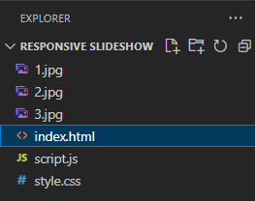

**Code Snippets**

**HTML:**

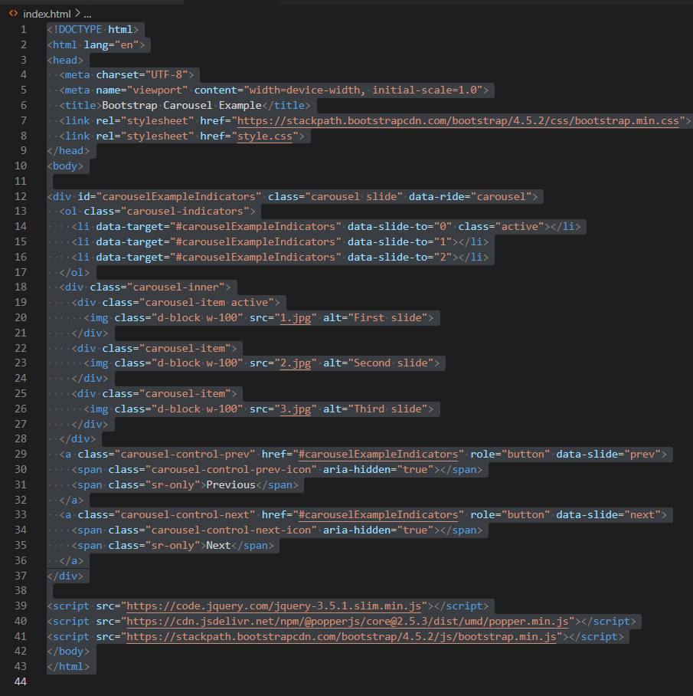

**CSS:**

/* Custom styles for horizontal carousel */

.carousel-inner {

  display: flex; /* Make the carousel items flex items */

  flex-direction: row; /* Arrange items horizontally */

}

.carousel-item {

  width: 100%; /* Ensure each slide takes up the full width */

  transition: transform 0.6s ease; /* Add smooth transition effect */

}

.carousel-item.active {

  transform: translateX(0); /* Set active slide to initial position */

}

/* Move inactive slides off screen */

.carousel-item-next,

.carousel-item-prev {

  position: absolute;

  top: 0;

  width: 100%;

}

.carousel-item-next {

  transform: translateX(100%); /* Move next slide off to the right */

}

.carousel-item-prev {

  transform: translateX(-100%); /* Move previous slide off to the left */

}

/* Custom styles for horizontal carousel with responsive images */

.carousel-item img {

  max-width: 100%; /* Ensure images don't exceed the width of the screen */

  max-height: 100vh; /* Set the maximum height of the images to the height of the viewport */

  width: auto; /* Allow images to scale proportionally */

  height: auto; /* Allow images to scale proportionally */

}

/* Custom styles for horizontal carousel with faster transition */

.carousel-item {

  transition: transform 0.3s ease; /* Reduce transition duration for faster response */

}

**Javascript:**

// Activate the carousel on document ready

$(document).ready(function(){

  $('.carousel').carousel();

});

// Optional: Pause the carousel on hover

$('.carousel').hover(function() {

  $(this).carousel('pause');

}, function() {

  $(this).carousel('cycle');

});

**Results**





**References**

<https://getbootstrap.com/docs/4.0/components/carousel/>

<https://codepen.io/tag/bootstrap-carousel>